Course: Programming Fundamental –ENSF 337

Lab #: Lab 2

Instructor: M. Moussavi

Student Name: Jiho Kim

Lab Section: B01

Date submitted: Sept 24, 2019

Exercise D part 2

|  |  |  |  |  |
| --- | --- | --- | --- | --- |
| Run# | Your Inputs | What is the value of n | What is the value of i | What is the value of d |
| 1 | 12 0.56 | 2 | 12 | 0.560000 |
| 2 | 5.12 9.56 | 2 | 5 | 0.120000 |
| 3 | 12 ab | 1 | 12 | 1234.500000 |
| 4 | ab 12 | 0 | 333 | 1234.500000 |
| 5 | 5ab 9.56 | 1 | 5 | 1234.500000 |
| 6 | 13 67 | 2 | 13 | 67.0000000 |

Exercise F

**CODE**

//name: Jiho Kim

#include <stdio.h>

#include <stdlib.h>

void get_user_input(double* distance, double* speed);

void travel_time_hours_and_minutes(double distance, double speed, double *hours, double *minutes);

void display_info( double distance, double speed, double hour, double minutes);

int main(void)

{

double distance, speed, hours, minutes;

get_user_input(&distance, &speed);

travel_time_hours_and_minutes(distance, speed, &hours, &minutes);

display_info(distance, speed, hours, minutes);

}

void get_user_input(double* distance, double* speed)

{

printf("Please enter the travel distance in km: ");

scanf("%lf", distance);

printf("\nNow enter the vehicle's average speed (km/hr): ");

scanf("%lf", speed);

}

void travel_time_hours_and_minutes(double distance, double speed, double *hours, double *minutes)

{

*hours = (int) (distance/speed);

*minutes = ((distance/speed) - *hours) * 60;

}

void display_info( double distance, double speed, double hour, double minutes)

{

printf("\nYou have travel %.2f (km) with a speed of %.2f in %.2f hour(s) and %.2f minute(s)", distance, speed, hour, minutes );

}

**Sample input/output:**

Please enter the travel distance in km: 5.44

Now enter the vehicle's average speed (km/hr): 76.5

You have travel 5.44 (km) with a speed of 76.50 in 0.00 hour(s) and 4.27 minute(s)

Please enter the travel distance in km: 125.5

Now enter the vehicle's average speed (km/hr): 65.5

You have travel 125.50 (km) with a speed of 65.50 in 1.00 hour(s) and 54.96 minute(s)

Please enter the travel distance in km: 125

Now enter the vehicle's average speed (km/hr): 65

You have travel 125.00 (km) with a speed of 65.00 in 1.00 hour(s) and 55.38 minute(s)

Please enter the travel distance in km: 100

Now enter the vehicle's average speed (km/hr): 50

You have travel 100.00 (km) with a speed of 50.00 in 2.00 hour(s) and 0.00 minute(s)

Please enter the travel distance in km: 50

Now enter the vehicle's average speed (km/hr): 100

You have travel 50.00 (km) with a speed of 100.00 in 0.00 hour(s) and 30.00 minute(s)

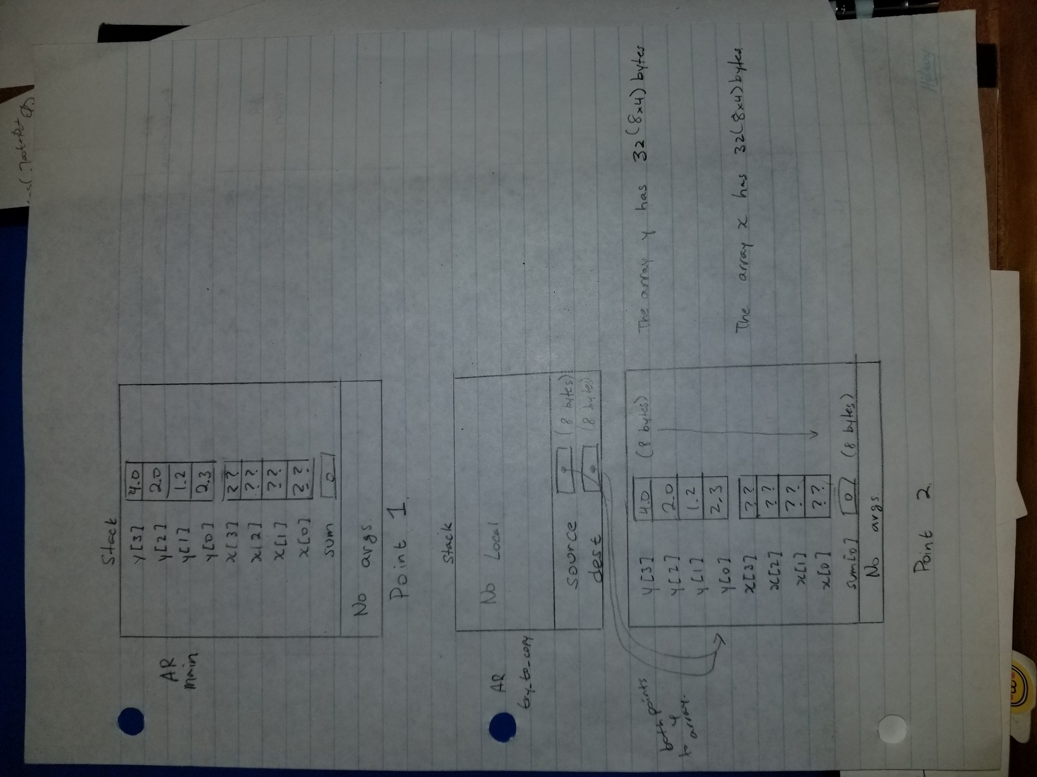

Point 2

Point 1

figure 4


Point 3

Point 4